
Weekly Roundup

Friday, December 6, 2024
Volume 1, Number

Dear MeVa Advisory Board Members—Thanks for helping christen the new McGovern Station Community Room yesterday. The Community Room is part of our larger vision for McGovern as an active, welcome space for the larger community that will be unfolding over the next year plus.
As was discussed at last month’s retreat and yesterday’s report out, board members expressed a desire to be more active and for greater communication between board meetings. In this spirit, here is the first installment of the MeVa Weekly Round Up!
1. Did you know MeVa is on call to provide bus support to public safety personnel and residents in the wake of home fires and other natural disasters? We’d love your help to keep our contact list up to date to better serve your communities in case of fire or other emergency situation. Please fill out the attached form at your earliest convenience or send it along to the person in your community best suited to provide us with this information.
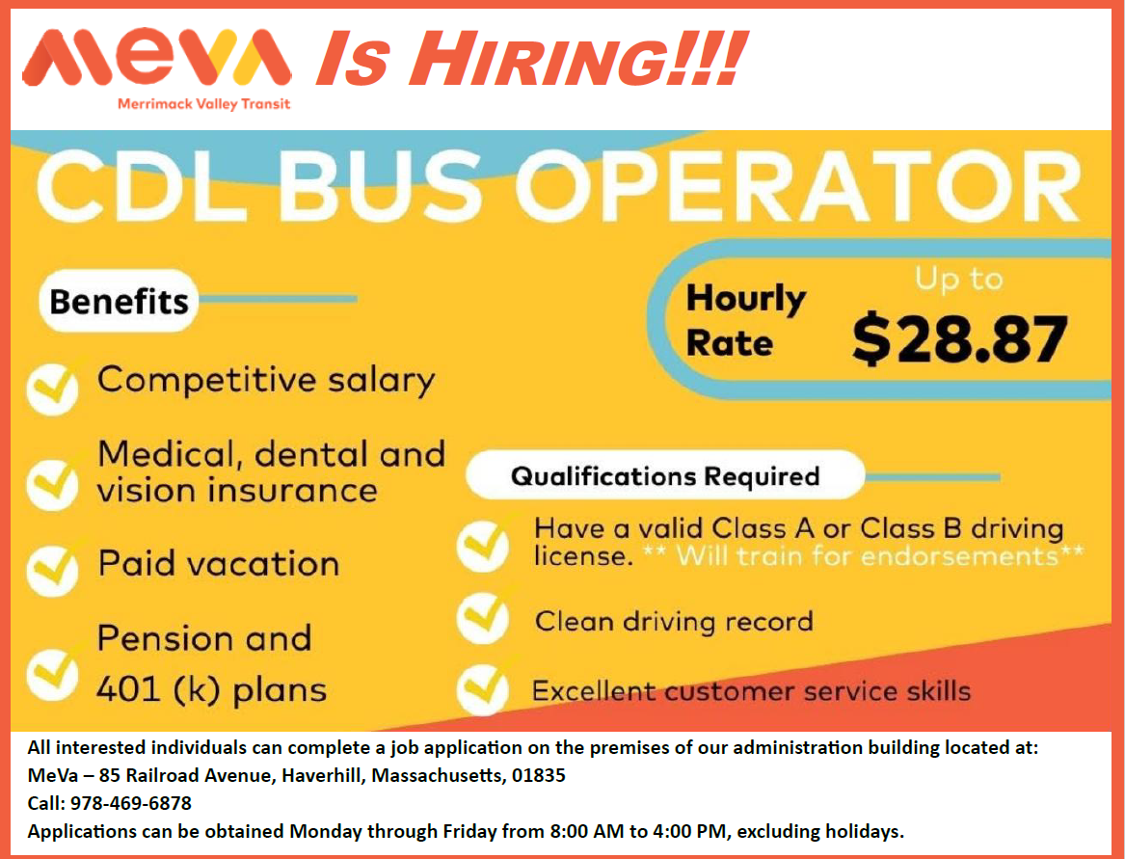
2. In case you missed it, MeVa is hiring! We have immediate openings for drivers with their CDLs. We will train for passenger and airbrakes endorsements. Please share the attached flyer widely!

3. We want to make sure riders and potential riders in your community know about our services. If there are organizations in your community that could benefit from a visit from the MeVa Outreach Team, feel free to connect us. Also, you know your communities best. If there is a community bulletin board, weekly newsletter, or other communication that is a “go-to” place for information for your residents, we’d love to learn more about it so we can be sure to share updates about our service there.

Thanks for reading along! Remember you’re welcome to join our employee Holiday Luncheon next Friday, December 13th, anytime from 11:30AM-4:00PM at MeVa headquarters in Bradford.

Weekly Roundup

Friday, December 13, 2024
Volume 1, Number 2

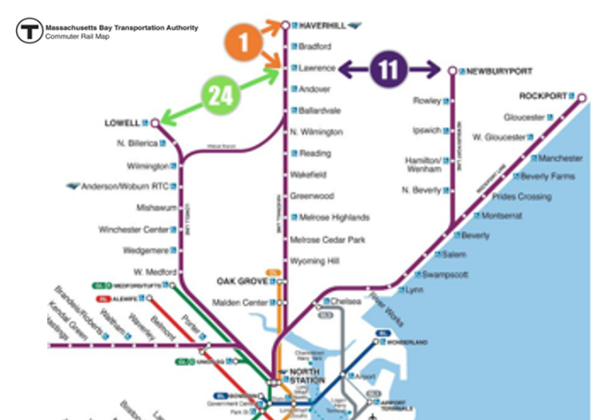
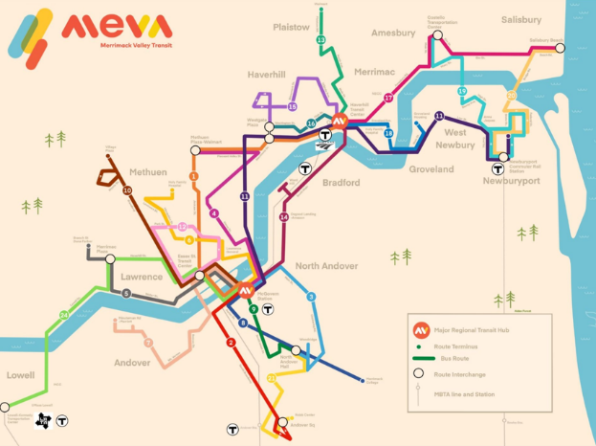
- Did you know that with the introduction of the new #11 bus this past September, MeVa provides direct connections between 4 MBTA Commuter Rail Stations (Lowell, Lawrence, Haverhill & Newburyport) and 3 MBTA Commuter Rail lines (Lowell, Haverhill & Newburyport/Rockport)? Thanks to these MeVa-MBTA connections, MeVa offers people living, working and visiting the Merrimack Valley more options for getting to and from the greater Boston area.
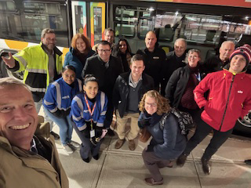
- MeVa hosted the Federal Transit Administration (FTA) yesterday in the same Community Room we met in as a board last week. The meeting was an opportunity for us to showcase both the vision for McGovern as a dynamic and welcoming intermodal transit station, already in operation, as well as the unfolding goal of activating and enlivening McGovern as a vital community space. The meeting was also an opportunity to showcase the innovations we have implemented over the past several years, our industry leading performance, as well as the projects we are looking forward to in the short and longer term. FTA Regional Administrator Butler commended MeVa’s leadership in the transit industry, noting how impressed he was with McGovern as an intermodal transit station, as well as MeVa’s responsiveness to the community, and delivery of robust public transit.
FTA Regional Administrator Peter Butler (foreground) and members FTA staff pose with team MeVa in front of a MeVa bus at McGovern Station

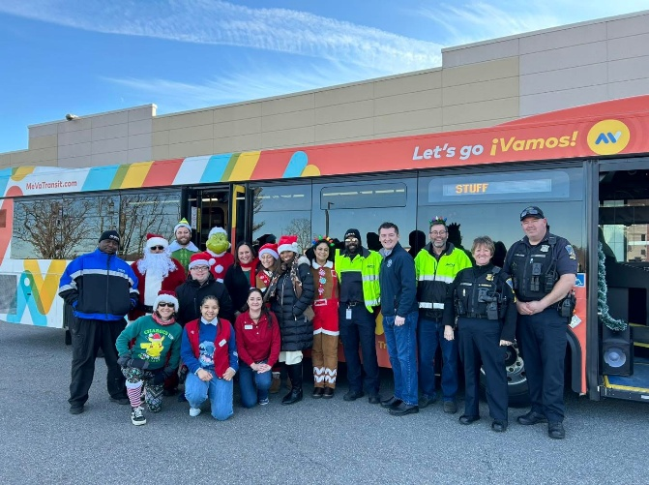
- Thanks to everybody who participated in our Stuff-a-Bus Toy & Clothing Drive at the Haverhill and Methuen Targets last week and to everyone who donated items to the cause! It was cold, but some of us were layered up in Santa 🎅and other costumes! And more importantly, we received a busload 😁🚌🚌🚌of donated toys, clothing & food 🎁🧸 🪀👕🥫which will go to children across the Merrimack Valley through our partners at Debbie’s Treasure chest & Neighbors in Need. Many thanks to the Methuen Police Department for dropping off bags of toys, the teams at both Targets for donating carts of food and gifts, and to State Senator Barry Finegold and State Representative Ryan Hamilton for stopping by. All told, we donated over 5,000 toys, clothing & food this afternoon, which will make this holiday season that much warmer for families across the Merrimack Valley. Thanks to the whole MeVa Team for making this event special and putting their hearts and souls into the effort!
Team MeVa at the Target in Methuen, along with the Methuen Police Department, Target staff, State Rep Ryan Hamilto, Santa, Buddy the Elf, the Grinch, and assorted Gingerbread People
Weekly Roundup

Friday, December 20, 2024
Volume 1, Number 3

- MeVa has made adjustments to our Winter Schedule, which starts Sunday January 5, 2025, in order to best reflect actual run times in the field and be responsive to the needs of our riders. While most of the changes are minor, the new schedule includes a more dramatic improvement to the #14 bus between Lawrence and Haverhill via route 125, including Ward Hill and the Amazon Distribution Center at Osgood Landing—Namely, we are doubling the #14’s weekday frequencies and will be running every half hour! Details about the new schedule are below and on our website: https://mevatransit.com/alerts/all-about-our-move-to-mcgovern/
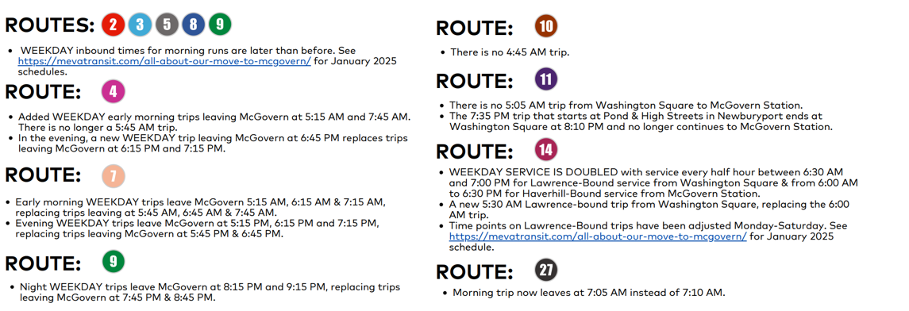
- As of this writing, Congress has yet to pass a funding bill that will keep the Federal Government open and operational after midnight tonight. What are the impacts for MeVa if a shutdown is not avoided? Short-term, we should be unaffected. Our federal funding agency, FTA, is funded under the highway trust fund, so will be fully operational. FTA has reached out to grantees, including MeVa, to reassure us that they will continue to make payments to grantees seeking to draw down funds for existing grants. Grants will continue to be processed and the FTA payment system will continue to process reimbursement requests, and the U.S. Treasury will continue to electronically reimburse recipients. All FTA financial, acquisition and travel systems will be fully operational and all FTA contracts, grants, and cooperative agreements will continue to perform in accordance with the terms of the individual awards. Our one grant currently under review, has just received certification from the Department of Labor today, which is significant since, unlike FTA, DOL employees will be furloughed in the likely event of an appropriation lapse. Longer term, we cannot move forward with anything in our capital plan that relies on FY2025 funding, although we do have some carryover formula funding that will sustain us for the time being.


- Do you have any Last-Minute Holiday Shopping to do? If so, you can take MeVa to all of your favorite shopping locations & avoid the hassle of fighting for scarce parking spaces! Spread the word!
As a reminder, we will not be operating on Christmas or New Year’s Day. We will be running a normal schedule on December 26, December 31 and January 2, 2025. We will be ending service early on Christmas Eve, with the last bus beginning its last run at about 4:00PM or 4:30PM, depending on the route. See schedule for details: https://mevatransit.com/alerts/christmas-eve-christmas-new-years-day/

From all of us at team MeVa, we wish you and yours a fabulous holiday and a joyously festive season!!! ❄️🎁🎄🎅🚍😎🦋🎍🎉⛄
Weekly Roundup

Friday, December 27, 2024
Volume 1, Number 4

- Three years ago, the CBA with the union representing our paratransit drivers, Teamsters Local 170, was not ratified until 12 months after the previous contract had expired. My mom used to say that “sometimes someone has to be the grownup.” Seeking to avoid the contentious, charged negations we experienced last go around, this time management embraced my mom’s mindset and came to the table in the spirit of fairness, collegiality and trust. As a result, the bargaining table proved to be a much more collaborative and mutually-respectful space this year. I am pleased to report that a contract has been agreed to and signed by both sides, well before the 12/31/2024 expiration. For year 1, top miniMeVa driver wages rise from $21.33 per hour to $24.00 per hour—a 12.5% increase, with 3.5% increases in year 2 and 3, keeping us aligned with the market.

- With on-going debate going on across the Commonwealth regarding future funding for transportation and the anticipated release of a set of recommendations from the Governor’s Transpiration Funding Task Force, our friends at Transportation for Massachusetts (T4MA) issued a bold report this month titled “Funding Our Future: A Roadmap for Equitable and Sustainable Transportation Action in Massachusetts.” The report, in their words, “sets the table for transportation funding discussions [and] provides a roadmap for fair, sustainable, and community-centered transportation funding, shaped by extensive grassroots input and real-world insights from across the state.” At MeVa, we appreciate that the report does a good job of highlighting the important role of RTAs in the state, and emphasizes that if we only focus on the fiscal cliff facing the MBTA without shoring up the financial situation of RTAs, it will be at our collective peril. In particular, note the breakout on RTAs on pages 15-16, which includes a recommendation that the Commonwealth pay off the annual Revenue Anticipation Notes (RANs)—a suggestion of the MeVa board last Spring: https://t4ma.org/funding-our-future/

- As this is the New Year addition of the Weekly Roundup, let’s reflect on the year that was: Perhaps the greatest demonstration of all of our collective work over the past year is that we carried 1.1 million more riders than we did in 2023. We began the year introducing Sunday service, adding service on all but a handful of holidays, and launching a new mediMeVa connection to the Bedford VA for veterans and their families, thanks to the addition of Fair Share amendment funds for RTAs with the help of our legislative delegation. We received a discretionary award from MassDOT to run workforce-targeted service in the Spring, which launched in September to great success. We introduced new, easier-to-access vehicles to our miniMeVa fleet, which allows us to be more nimble and responsive to our paratransit customers. We also opened our new Lawrence hub at McGovern Station, inclusive of a new drivers’ lounge and community room. The new station is already an active hive of activity that will only grow. While we experienced unexpected leadership turnover on the operations side this year, it has been gratifying to see MeVa staff take on the challenge of new positions and absolutely rise to the occasion, with a renewed commitment to teamwork, collaboration, creativity and responsiveness. As a result, we are in a much better position than we have ever been. Big thanks to the entire MeVa team who puts the work in day in and day out and makes MeVa shine, from reservationists, to office staff, to mechanics, to maintenance crew, to drivers. Thanks to our riders and community partners—they are the reason we are here and why we get up in the morning with a passion and enthusiasm for service. And thanks of course to you, our board, for supporting what we do in the community and on Beacon Hill, hold us accountable, and challenge us to continue to think big! I am so proud of all that MeVa does and has accomplished.

Happy New Year—here’s to all good things in 2025!!!🎉🎆🧨🚍

Weekly Roundup

Friday, January 3, 2025 27
Volume 1, Number 5

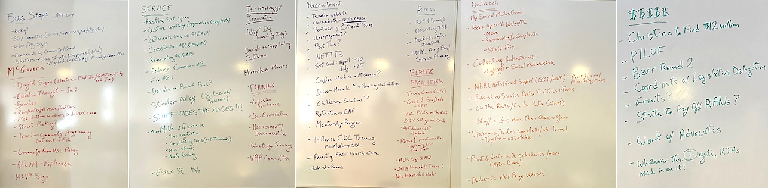
- MeVa’s Goals for 2025: As we welcome 2025, the MeVa team set out to identify our goals for the coming year and put them in writing. We have a lot to look forward to this year, including transitioning to bus stops, activating McGovern Station as a welcoming community space, continuing to grow and optimize service that is responsive to regional needs, aggressively recruit and retain drivers so that we are able to deliver that service, innovate with cutting edge technology, be even more visible and active in the community, and work across the Commonwealth and at home to identify long term revenue streams to allow us to continue to provide our community with the accessibility they need and deserve!
- Driver Recruitment & Training: As of this coming Monday, January 6, 2025, we will have 94 Bus Operators on the books, which is the most we have EVER had! Included in this number are three new hires that will start training on Monday. Four of our most recent trainees have recently passed their endorsement tests and will be released to drive on their own next week. We also promoted a miniMeVa driver who passed his CDL test yesterday. In the spirit of our aggressive recruitment campaign, we are striving to “think outside the bus,” and identify creative ways to get people in the door. One idea is to promote that we provide free health care for an operator’s whole family!

- Our drivers are beloved by our passengers! Bus drivers make a tremendous impact on the riders that use our service. One passenger recently expressed his appreciation in a song he composed and recorded in honor of long-time MeVa driver Tracy Bagley, who is a fixture on the #14! The heartwarming song is attached—take a listen…and maybe grab a Kleenex.

Weekly Roundup

Friday, January 10, 2025
Volume 1, Number 6

- Winter Schedule Launches: This past Sunday, we kicked off our Winter bus schedule. The most significant change was increasing frequencies on Route #14 from every 60 minutes to every 30 minutes in response to growing ridership over the last quarter. Back in April 2024, thanks to a discretionary grant from MassDOT, we were able to extend the #14 from McGovern Station to Washington Square along Rte. 125 and Sutton Street to serve the new Amazon Distribution facility as well as Ward Hill. By interlining the #4 and #14, we were able to enhance operational efficiency and utilize excess layover time to increase frequency of the #14 at limited additional cost. Interestingly, while the #14 has, as intended, been utilized by workers at Amazon and Ward Hill businesses, it has also been used by riders seeking alternative options for travel between Lawrence and Haverhill, as well as riders accessing the North Andover Senior Center, and Sutton Street housing. Other changes introduced this week include adjusting timepoints on the schedule for certain routes in order to better reflect actual bus experiences on the road. For the first time in our history, some routes now show different time points in the morning than in the afternoon, in recognition of very different traffic conditions at different times of day. So far, the new schedule has resulted in better on time performance and customer satisfaction!

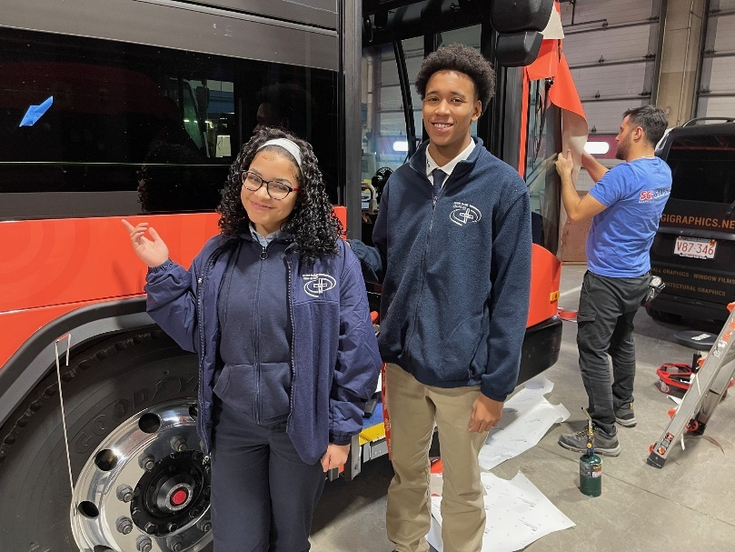
- Welcoming MeVa Interns from: This week MeVa welcomed interns Kenny, Ashley, and Daran, from Notre Dame Cristo Rey Academy in Methuen. These three students are joining us as part of their Corporate Work Study Program, working one full day per week from now until June. After subjecting them to a tour of our facility and an over-the-top lecture on the value of bus transportation, we put them to work! During their time here, they will be assisting with general office duties such as filing, preparing outreach packages, stuffing envelopes, and building our contact database. They will also be supporting Tim in the IT department, helping us up our social media game, and preparing marketing flyers for existing and new outreach programs. In addition to loving the injection of youthful enthusiasm and curiosity into our operation, all of us at MeVa take seriously the importance of training the next generation of public transportation professionals, mindful that we may be developing a future MeVa Administrator, General Manager, or Board Member.
Interns Ashley and Daran from Notre Dame Cristo Rey Academy in Methuen witness the wrapping of MeVa’s newest buses.

- Remembering Jimmy Carter: Yesterday, all federal offices were closed in a National Day of Mourning to honor the legacy of our 39th President, Jimmy Carter, who died last week after reaching the century mark. Not to make this all about us, but 100 years is twice the age of MeVa. When he began his presidency, we were still in our infancy and, like President Carter, we continue to grow our impact in communities we serve. Many of the comments honoring the late president suggest that he accomplished more in the years since his presidency than he did while in power. To me, that is both unfair and misses the point of his enormous legacy. The key, for me, is how can we be a force for positive change, regardless of what official authority we may hold and recognize that influencing without authority might have the most lasting positive impact? While it is harder to make a positive change than a negative one, true leaders will strive for the former and, like President Carter, do what they think is right regardless of personal or political consequences. I am inspired by the reflections of his grandson, Jason Carter, who observed that “I never perceived a difference between his public face and his private one. He was the same person, no matter who he was with or where he was. And for me, that’s the definition of integrity.” That is a fabulous model for all of us to follow.

Weekly Roundup

Friday, January 17, 2025
Volume 1, Number 7

- Good Bye Andrew & James/Welcome Christian & Adrienne! With the start of the new year, the composition of our board is changing. Longtime members Andrew Levine of Newburyport and James Ryan of Salisbury were both appointed to Town Administrator positions in Hatfield & West Boylston, respectively. While we will miss Andrew and James, both of whom were active board members who were committed to MeVa’s mission and added tremendous value both at the board and committee levels, we are proud to see local Merrimack Valley talent blossom in other corners of the state! We are also excited to welcome new board members Christian Cyr of Newburyport and Adrienne Linnell of Salisbury to team MeVa. We look forward to working with them to help us deliver for Merrimack Valley’s residents, workers and visitors, and sharing empanadas with them at our next board meeting in February!
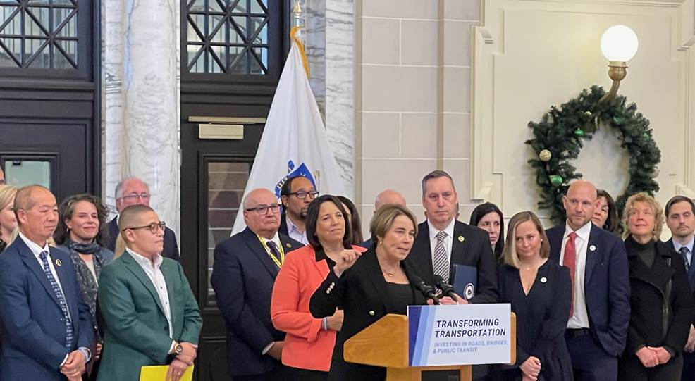
- Transforming Transportation: On Tuesday, I joined many of my fellow RTA administrators, other transportation leaders, and advocates at a pivotal announcement by Governor Healey, made over a bold banner reading “Transforming Transportation: Investing in Roads, Bridges, & Public Transportation” at the Great Hall in Worcester’s Union Station. In a departure from past transportation announcements in the state, the press release from the Governor’s office referenced Regional Transit Authorities in the headline. The Governor, Secretary Tibbits-Nutt, and other speakers all mentioned the importance of RTAs to our regional economies at multiple opportunities during the event. Lieutenant Governor Driscoll even wore a MeVa-colored jacket! The Governor committed to investing $8 billion in transportation over the next 10 years. The work has only just begun. While the primary source of funding identified will be revenues from the Fair Share amendment, which has been performing favorable to expectations, new revenue streams will need to be identified for the long term. For the short term, while much attention has been paid towards addressing the MBTA’s operating deficit and paying down the T’s legacy debt, the Governor did pledge to fund RTAs in FY26 at over $200 million and renew discretionary free fare and interconnectivity grant programs in H1, which will be submitted next week. While the devil will be in the proverbial details, it is auspicious that in recent years, H1 has set the base funding amount, that only gets increased in the House and Senate budgets. Stay tuned!
MBTA General Manager Phil Eng, Secretary Monica Tibbits-Nutt, Lieutenant Governor Kim Driscoll (in MeVa coral😊), Governor Maura Healey, and members of the Transportation Funding Task Force at Worcester Union Station

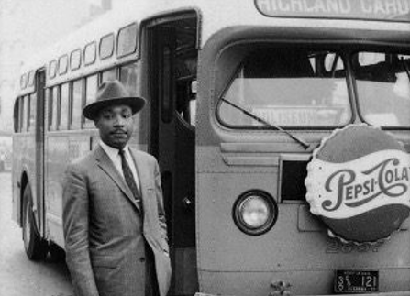
- Martin Luther King Jr. Holliday: This Monday, our buses will be running on a Saturday schedule, as the day is a national holiday honoring the legacy of Dr. Martin Luther King Jr. For those of us working in transportation, it is inspiring, noteworthy and prescient that Dr. King recognized and acted on his understanding that access to public transportation is a civil right and the key to opportunity, access, and inclusion. In 1955, Dr. King led the Montgomery Alabama Bus Boycott, which Historians mark as the first major demonstration against racial discrimination in this country and what launched the modern civil rights movement. Thank you Dr. King for seeing that public transportation is the key to everything and for striving to break down barriers to equal access for all. The entire MeVa team and our riders will be thinking about this important lesson on Monday.
Weekly Roundup

Friday, January 24, 2025
Volume 1, Number 8


- Baby it’s Cold Outside! We have endured particularly bitter cold weather this week. At 4:30AM this past Wednesday, the thermometer read 1 degree above zero Fahrenheit as we began our service day. Our ability to operate smoothly and reliably for our customers is only possible due to the hard work and dedication of our workforce. Our mechanics arrive early to begin the choreography of moving buses which, in our case, is a special art. Since we do not have the storage capacity for all 74 of our buses to be under cover, 30 buses remain outside overnight. When it snows, our team clears snow off the outside buses by running them through the bus wash. Drivers then conduct pre-trip safety inspections of their buses before heading out to do their runs. This step is especially important during extreme cold and snowy weather, to ensure windshield wiper blades, fluids, and heating systems are all fully functional. The key to smooth operations - regardless of weather - is the ironclad commitment by our mechanics to performing year-round preventive maintenance of our buses’ complex systems. The turbo air dryers, which keep the moisture out of the air system, are overhauled every two years; the auxiliary heaters (Pro-Heat) that supplement the buses’ heating system are maintained every 6,000 miles as part of year round PM; batteries are tested regularly with a special tool that checks battery life; fuel pro filters heat the diesel fuel to keep it from gumming up; and since the urea in the diesel exhaust fluid (DEF) freezes at 12 degrees Fahrenheit, the DEF tank has a heater in it as well. So next time we wake up and the thermometer is reading another ungodly number, please think of the dedicated MeVa crew toiling in the tundra!

- Proposal for Commonwealth to Pay Off RTA RANs: On Tuesday, I presented to the Massachusetts Association of Regional Transit Authorities (MARTA) a proposal for the Commonwealth to use one-time surplus Fair Share amendment funds to pay off all of our Revenue Anticipation Notes (RANs). The idea for doing so was first raised at a MeVa Advisory Board meeting last spring when we were reviewing the FY25 MeVa budget. While RANs are a useful tool to give RTAs the cashflow to continue operating at the start of the fiscal year before state operating assistance funds are made available, the reality is that the bulk of the borrowing actually goes towards paying off the previous year’s note. While all of us RTAs are working through the Governor’s just-submitted FY26 budget, as well as the potential use of surplus Fair Share funds to be included in an FY25 supplemental budget, this may be a good use of one-time funding. The full proposal in the form of a memo is attached to this email.

- All Rise: On Wednesday, I was called to jury duty at the Middlesex Superior Court in Woburn. While I did not get selected for the jury, and spent a lot of time waiting with the entire 60+ members of the jury pool, it was not lost on me that serving on a jury when called, along with voting, is a key obligation of citizenship and did find the experience inspiring. I appreciated the judge’s patriotic reminder that we are the only country in the world that guarantees the right to trial by a jury of ones peers for every trial, criminal or civil. As it’s all about transportation, I was less inspired by the actual siting of the courthouse, in an office park off of the highway, remote from public transportation, or even a place to walk to to grab a cup of coffee or a bite to eat. To ensure that juries are composed of a true representation of our community, courthouses should all be accessible by public transportation. Here in the MeVa service district, I am proud that we serve each and every one of our courthouses. The Essex Superior Courts in Lawrence and Newburyport are on the #1, #5, #10 & #12 and the #11, #19 & #20, respectively, and the Districts Courts in Lawrence, Haverhill and Newburyport are on the #1, #5, #10 & #12, the #13, and the #11 & #19, respectively. MeVa = Justice!

