MeVa Administrator’s Report to the Advisory Board
Noah S. Berger
February 6, 2025

Note: Welcome to the leaner & meaner Administrator’s Report, which is Based on feedback from the MeVa Advisory Board retreat in November. In the interest of brevity, I am attaching all Weekly Roundups sent since the last board meeting in December for reference and mostly do not repeat items covered therein. The less loquacious Administrator’s report has also been moved to the end of the agenda in order to give adequate time to other pressing agenda items coming before the board.

State of Administration

- Staffing Update
We are forging ahead with our aggressive hiring campaign. Since November, 8 bus operators have completed all training, received all needed endorsements, and are now driving on their own in revenue service. Additionally, since our December board meeting, we have hired 4 CDL bus operators, 3 miniMeVa paratransit operators, as well as 1 miniMeVa reservationist and 2 wash rack staff. Also, on Monday, February 10, we’ll be adding four new bus operators, and a new class of miniMeVa paratransit operators is starting the following Tuesday, February 18. While these new hires have allowed us to bring back Saturday service, we are targeting adding 10 drivers by start of the April schedule and 25 by the start of the July schedule in order to meet our aggressive service goals.
.
- Launch of CDL Training Incentive Program
Historically, some of our most successful drivers have come from the ranks of our paratransit driver pool. In an effort to build out this career advancement pipeline, we have launched an incentive program to further encourage our van drivers to participate in CDL training. New employees who join MeVa with their CDL permit will start their career journey with three full weeks in paratransit training (1 week class with an in-house trainer, and 2 weeks behind the wheel). Once they are released on the road alone, they will work part time as a miniMeVa operator and part time as a CDL Trainee – all while bring paid! They will have 12 weeks to get their CDL and receive their Class B License. Once they are fully licensed, they will move from miniMeVa to fixed route and begin route training. As of right now we have one new employee that will start this program on February 18.

In addition, we are offering a bonus program to entice current miniMeVa operators to move to the Fixed Route bus side. Any current miniMeVa operator hired before January 7, 2025, will receive a $1,000 bonus if they get their CDL and move to transfer to bus operations before December 31, 2025. They will need to be a bus operator for 60 days before receiving the bonus.

State of Operations:

- Ridership
Fixed Route ridership remains stagnant through January, reflecting both typically lower ridership this time of year and impacts of temporary reductions in Saturday service. As of February 1, we have now gone back to our full Saturday span and half-hour headways on the #1, so ridership should be on the upswing again this month and following. Even with this setback, we are still on track to carry 3.1 million riders this fiscal year, which will be an all-time high, and 7.5% greater than last year’s ridership and 58.5% greater than our pre-pandemic (FY2019) ridership.

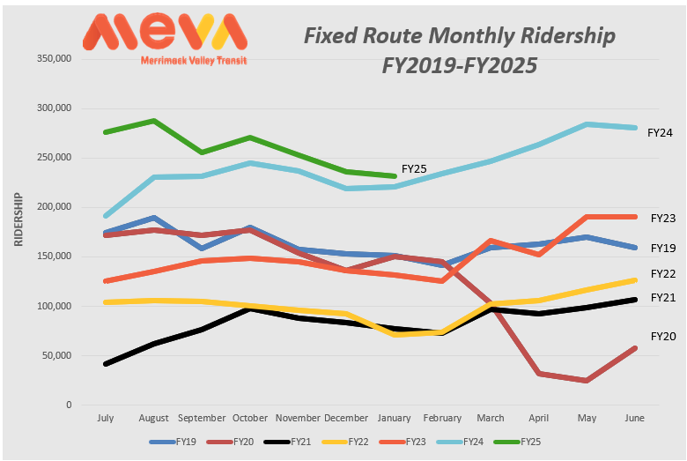

Paratransit (miniMeVa) ridership has not experienced the same stagnation as Fixed Route, which makes sense since miniMeVa’s service did not experience a reduction in Saturday span. miniMeVa is on track to carry 114,993 riders this fiscal year, which will be an all-time high, and 13.7% greater than last year’s ridership and 26.8% greater than our pre-pandemic (FY2019) ridership, indicating that while paratransit ridership has not grown at the same rate as Fixed Route with respect to pre-pandemic levels, it is currently growing faster than Fixed Route.

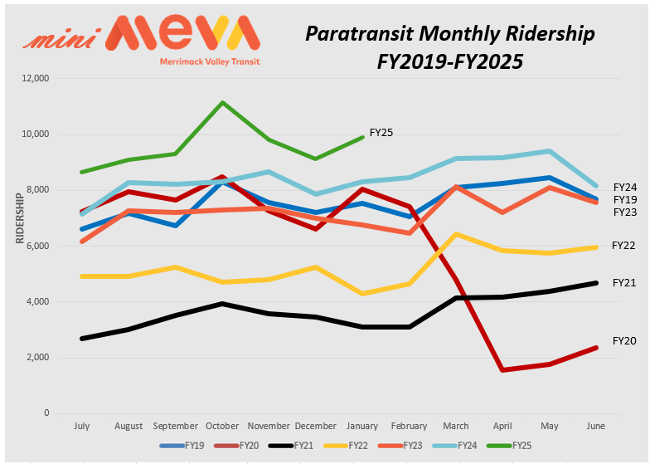

- Service and Operations Planning
With the success of our driver recruitment effort, we have begun the process of expanding our level of service and now have the following plan for service restoration and expansion:

- February 1, 2025: Restoration of full Saturday service, including span (7:00AM to 7:00PM on the #1 & 7:00AM to 6:00PM on all other routes) and 30-minute frequencies on the #1 for most of the day. DONE ✅
- April 6, 2025: Restoration of full, all day 30-minute weekday service on all Lawrence routes
- July 6, 2025: Weekday frequencies increased from every 30-minutes to every 20-minutes on the #1 & #24.
- September 7, 2025: Introduction of new crosstown service in Lawrence, Methuen, Andover and North Andover.

State of Finance:

- Status of Federal Funding
With the recent flurry of Executive Orders and funding pauses - followed by the pausing of the funding pauses, and subsequent rescinding of the initial pause – compounded by a lack of guidance from our federal partners (who are as much in the dark as the rest of us) we are all experiencing a bit of whiplash and uncertainty. Needless to say, there is considerable anxiety amongst all recipients of federal funding, but little to actually report. In evaluating the availability of funding at MeVa’s disposal, it is important to distinguish between funding that has been obligated, appropriated, and authorized. All of our current federal funding has already been appropriated by Congress, who has the power of the purse, and almost all of that has already been obligated in FTA grants. It is the general consensus amongst constitutional scholars and the greater legal community that these funds cannot be impounded based on the separation of powers articulated in the Constitution and existing law. Less secure are funds already authorized in the Bipartisan Infrastructure Law, but not yet appropriated. That said, since the authorization sets out the parameters for future appropriations by program and formula allocation through September 2026, there is less ability to subvert programs or funding distributions, although across the board funding reductions by Congress would not be prohibited. Funding in this category includes the not-yet passed FY2025 and FY2026 appropriations.

We currently rely on FTA funding for 28.9% ($9,412,700) of our operating budget, for preventive maintenance, ADA operating (drivers and fuel), and fixed route operating under the under 100 bus rule. We also rely on FTA funding for 80% ($6,766,270) of our capital program, including the relocation of an aging underground diesel fuel tank and the design and construction of a needed retaining wall at our maintenance facility, the annual bus ReGen and equipment rehab of our older buses, including the already-started powertrain replacement of our 2018 buses (engines, transmissions, radiators, etc.), and the expansion of our successful demo of the mirrorless mirror system to all 32 our BRT-style buses to eliminate blind spots and maximize safety. FTA operates on a reimbursement basis—in many cases, we have already incurred costs. In other circumstances, contracts have been signed with vendors. The bulk of anticipated FTA funding is allocated to census-defined regions by preset formula (we are one of 10 recipients in the 3-state Boston urbanized area). Discretionary funding, which we have never presumed in our budget, is allocated to individual grantees and, within the parameters of the funding programs, the executive branch can add priorities for funding. For example, §5339 bus and bus facilities discretionary funds must be used to pay for buses or bus facilities, but may also give preference to proposals that support expressed goals. That said, it is unclear what the difference between a “woke” and “non-woke” bus barn would be.

- State Funding
With all of the uncertainty with respect to federal funding, there is an opportunity for the state to step up and make a bold investment in RTAs. Two weeks ago, all RTA administrators were invited to the Great Hall in Worcester’s Union Station for the unveiling of Governor Healey’s Transportation Funding Task Force report. In a departure from past transportation announcements in the state, the press release from the Governor’s office referenced Regional Transit Authorities in the headline, and the Governor, Secretary Tibbits-Nutt, and other speakers all mentioned the importance of RTAs to our regional economies at multiple opportunities during the event. The Governor committed to investing $8 billion in transportation over the next 10 years. Much of these dollars would be drawn from revenues from the Fair Share amendment, which has been performing highly favorable to expectations. The following week, the Governor submitted H1, her FY26 budget, which funds RTAs at the same $204 million level we received in FY25, and includes the continuation of the discretionary free fare and interconnectivity grant programs. While level funding falls short of our need, it is auspicious that in recent years, H1 has set the base funding amount, which has then increased in the House and Senate budgets. While much attention has been paid towards addressing the MBTA’s operating deficit and paying down the T’s legacy debt, RTAs are in the same boat, only at a different order of magnitude, and due to our smaller size, have been nimble in responsively putting needed service on the road as funding has been made available. The legislature has indicated that they are very cognizant that all RTAs have delivered on funding increases received over the last 2 years and that we provide a vital service to our communities.

We are also monitoring the prospect of a supplemental budget for FY25 using Fair Share amendment surplus revenues. As this would need to be one -time funding that might need to be spent quickly, this could be an opportunity to use these funds to pay down RTA Revenue Anticipation Notes (RANs), an idea first proposed during MeVa’s June Advisory Board meeting.

- Open Federal Grants
MeVa currently has $13.6 million in unexpended funds available, representing 19.3% of original obligations. $5.2 million of the unexpended funds are COVID relief grants, which is 22.0% of our full COVID relief funding. All of these funds are already obligated and executed in existing grant agreements with FTA.

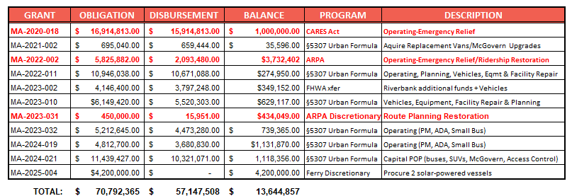

- FY24 Variance Report
Through the first seven months of FY2025, expenses are tracking according to budget. While we are currently $942,430 favorable to budget, that is primarily a function of the lumpiness of when costs and revenues are received.

FY2025 MeVa Budget to Actual through January 2025

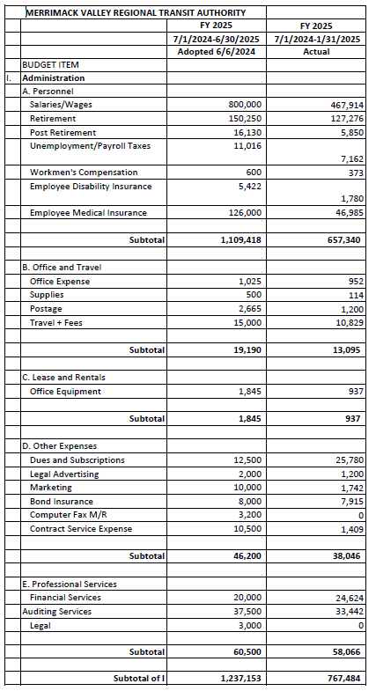
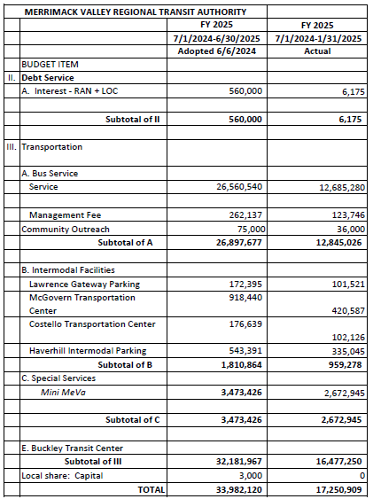
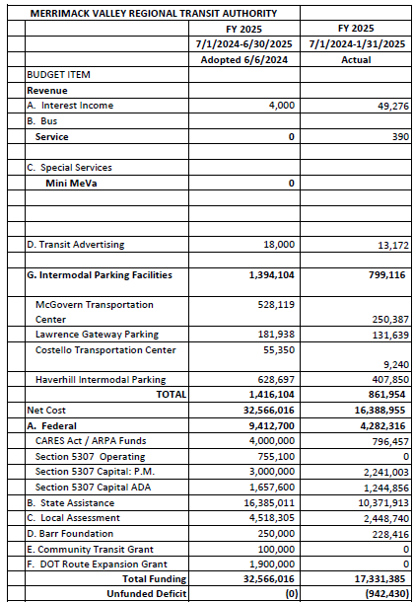

State of Planning & Implementation:

- American Training Coordination
On January 24, MeVa met with leadership at American Training, Inc. (ATI) at Campanelli Drive in West Andover. The meeting was spurred by a request from MassDOT, who noted overlap with our services and a grant application submitted by ATI for Community Transit Grant funding. Both MeVa and ATI identified multiple opportunities to collaborate, including travel training for their clients, MeVa referring to ATI for access to areas we don’t serve, and further promotion of the #7 bus, which goes right by their front door every 30 minutes.

- Human Trafficking Awareness
This past January was Human Trafficking Awareness Month. On Friday, January 24th, managers and safety and training officers participated in a webinar put on by NEPTA (Northeast Passenger Transportation Association) that reviewed actionable steps transit should take to become more aware. Sadly, there are 25 million victims of human trafficking worldwide, including here in the United States. Traffickers use all modes of transportation to conduct their activities, including public transit as it is open to all riders, and provides less direct interaction with government officials. Public transportation workers and riders are presented with the best opportunities to identify and report potential incidents of sex and labor trafficking. We already do include a human trafficking awareness module in our regular driver training and in one case a driver was able to utilize tools from the training to alert authorities to an instance of harassment of minor children aboard our bus.

- MBTA South Elm Street Bridge Project Outage Coordination
On January 15, the MeVa Team met with the MBTA construction management team to review plans for the final phase of the Elm Street Bridge replacement project located at the entrance to Railroad Avenue. The MBTA anticipates completing work in the roadway for tie-back installation in March. Haverhill detail officers are handling traffic management to allow buses to navigate through the work area. Temporary falsework for bridge construction will start in March, with traffic to be managed like the current operation with minimal impacts to MeVa service. Steelwork will begin in mid-April, which will require closing the South Elm Street intersection from Friday night through Saturday morning. During this time, buses will only be able to turn left out of Railroad Ave and only be able to access the facility from the Comeau Bridge, which will remain open. The intersection will again be closed from Thursday 5/29/25 at 11pm until Monday 6/2/25 at 5:00AM. From midnight on Friday 5/31/25 at until 5:00AM Saturday morning the entire intersection will be closed to all traffic to facilitate demolition equipment and activity. After 5:00AM, a single lane alternating traffic pattern will be implemented for the remainder of the weekend to allow MEVA to operate and support operations of MBTA commuter service at Bradford Station. Full depth reconstruction under the bridge footprint is scheduled for mid/late summer. The MBTA has committed to being a good partner and will work around MeVa’s service needs as the project progresses, including facilitating access for our overnight maintenance staff, and will update us monthly.

State of Outreach:

- Social Media Challenges
It is a point of pride at MeVa that our social media posts are open to and even encouraging of public comment. After all, we can only deliver the way we want to if we are willing to listen to what our riders have to say, good or bad. For the most part, comments have been constructive, respectful and polite. That said, we recently had a commentor who posted multiple mean-spirited invectives directed at another poster and members of their family. While we prefer to be on the receiving end of hateful rhetoric ourselves, our staff does not take it personally. However, when the vitriol is directed at others, it is not acceptable and will not be tolerated. As a result, we elected to shut down comments on the posts in question. We are currently reviewing how we as a public agency can best balance maintaining the open dialogue we value on social media, while being more proactive about limiting hurtful or bullying commentary directed at others.

- Meetings and Events
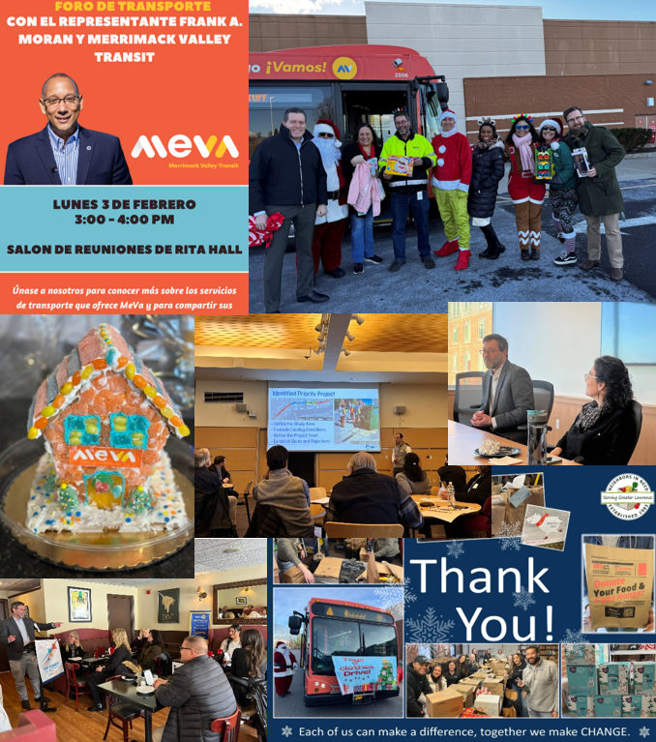

Key events that the MeVa team has participated in since the last board meeting include:

- 12/5/24: Stuff A Bus – Target Haverhill and Target Methuen
- 12/9/24: Andover Commons Outreach
- 12/10/24: Merrimack Valley Veterans Collaborative
- 12/11/24: Wellpoint Healthcare
- 12/12/24: Federal Transit Administration site visit to McGovern Station
- 12/13/24: Stuff A Bus and Debbie’s Treasure Chest
- 12/16/24: City of Haverhill Workforce Development Group
- 12/17/24: MVCulture Working Group
- 12/18/24: Notre Dame Cristo Rey
- 1/13/25: MVCC Mayors and Managers Event
- 1/14/25: Governor Healey’s Presentation on the Transportation Funding Task Force at
Union Station in Worcester
- 1/14/25: Development Directors Roundtable – Community Inroads
- 1/15/25: Eggs and Issues with the Greater Haverhill Chamber
- 1/15/25: MBTA – MeVa Bridge Reconstruction Coordination Meeting
- 1/16/25: Elevated Thought
- 1/21/25: Rotary Club of Greater Newburyport
- 1/22/25: MVPC Retreat
- 1/23/25: Merrimack College
- 1/24/25: American Training
- 1/25/25: MeVa-MVPC Bimonthly Coordination Meeting
- 1/26/25: Groundwork Lawrence
- 1/30/25: Metromobility Grant Coordination
- 2/3/25: Rita Hall Outreach with Rep Moran
- 2/4/25: MakeIt Haverhill

- Media
- Eagle Tribune, 12/7/24 – Report on MeVa holiday toy and clothing drive: https://www.eagletribune.com/news/merrimack_valley/meva-and-you-stuffed-a-bus/article_664118d8-b403-11ef-8eb5-23f0312d0aa7.html
- Eagle Tribune, 12/9/24 – Editorial commending MeVa on success and spirit of stuff a bus campaign: https://www.eagletribune.com/opinion/editorials/meva-stuff-a-bus-a-holiday-success-story-closure-of-substance-abuse-centers-troubling/article_e1c759ba-b514-11ef-8bbe-03a0d1bcc45c.html
- Eagle Tribune, 12/20/24 – Report on MeVa safety precautions added in the year since fatal pedestrian strike: https://www.eagletribune.com/news/haverhill/a-year-after-rare-bus-fatality/article_f9461566-be4e-11ef-b39d-0b4e80d34664.html
- WHAV Radio, 12/26/24 – Monthly segment with Win Damon
- The Town Common Weekly, 12/31/24 – Report on MeVa receiving MassDOT free-fare discretionary funding to extend fare-free initiative: https://thetowncommon.com/2024/12/31/taxpayers-additional-2-6-million-outlay-will-keep-meva-rides-free/
- WHAV Radio, 1/15/25 – Report on MeVa’s presentation at Haverhill Chamber of Commerce’s “Eggs and Issues” forum: https://whav.net/2025/01/13/commuter-improvements-focus-of-haverhill-chambers-eggs-issues-legislative-breakfast/
- WHAV Radio, 1/23/25 – Monthly segment with Win Damon
- Massachusetts Municipal Association Press Release, 1/30/25 – Report on election of new leadership at the MMA, highlighted by our own Mayor Kassandra Gove as the new Vice President: https://www.mma.org/jamie-hellen-is-new-mma-president-kassandra-gove-is-vp/

